Section 1:
Concept & Target users:
The website I am designing and creating is an online platform for a powerlifting coaching service. It aims to connect powerlifters with expert coaches no matter what experience they have (Beginner-Advanced) providing a tailored experience for each person through 1-on-1 coaching programs suited to a client’s flexibility. The website will provide educational content through the social media links to help lifters train smarter and avoid injury free of charge. The website will make professional powerlifting coaching accessible to users around the world with the purpose of helping powerlifters improve their strength, technique and confidence through evidence-based coaching as well as create a community of like-minded lifters and coaches who are focused on performance, education and support. The website will include information about the service that the coaching staff provide, the coaches that are available and what their strengths are, client testimonials as well as an area for Merchandise that can be purchased. The website will have a simplistic design avoiding overwhelming the user with too much information however it is important that the user can find all of the information that they would need to make an informed decision on which coach/service suits them best.
This is a strong concept as powerlifting is a niche but growing industry with a rapidly expanding global community. Many lifters are unable to access quality coaching services where they can receive tailored structured training which is what this website aims to do.
The Primary target audience of the website are intermediate and advanced powerlifters who may already have coaching and want to get the most out of them through a team of experienced coaches who can help them unlock the best version of themselves. No coaching experience is the same which means that we are still able to target users who have had previous experience in coaching or even users who are currently in coaching but are looking for a change in approach.

Persona 1:
Name: Milo Storer
Age:20
Occupation: Full- Time Student
Location: Glasgow
Hobbies:
- Powerlifting
- Film making
User Description:
I am a full-time student studying Sports science. I have been going to the gym for 4 years and powerlifting for 2 years. Currently I am on the University’s Powerlifting team and the club program that they give to everyone.
Goals:
Find information about a what the coaching service will provide and see what other people have thought of the coaching.
Needs:
I am not well versed with technology so I need obvious ways to navigate the website.
User Story:
As a busy student I want to be able to find information about each coach easily so that I can make a decision on what couch would fit my needs best.

Persona 2:
Name: Will Mcglauclin
Age: 28
Occupation: Full Time Accountant
Location: Stirling

Hobbies:
- Meeting with friends
- Running
- Climbing
User Description:
I work Full time in finance and enjoy running in my spare time. I have never been consistent in the gym and want to challenge myself with powerlifting for the first time.
Goals:
-Find information about how I can start powerlifting
-Find how I can get a plan that can be tailored around my work schedule
Needs:
A tailored coaching program as well as nutrition advice

User Story:
As I work full time I want a program and nutrition plan so that I can work it around my work schedule and start making progression in the gym.

The first persona represents a younger user who is already a powerlifter but wants to gain more out of his coaching. The second persona is an older user who works full-time, has never done powerlifting before and wants to find out how to start.

Section 2:
In this section I will evaluate and justify the design of the Apto Performance concept using UX and UI principles.
It was quite easy for me to imagine an initial design for the home page as I am an avid gym goer/ powerlifter so I wanted to create a home page that appealed to myself as I know what the target audience for the website is looking for.

Home Page:

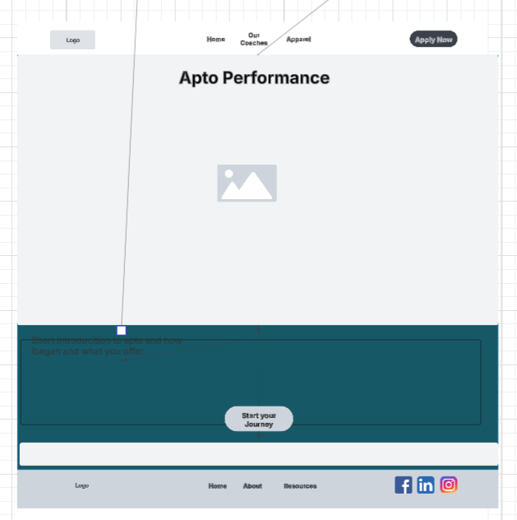

The page follows a consistent vertical structure making use of a navigation bar at the top, A hero section with a headline, image placeholder and introductory text as well as a call-to-action button centred at the bottom of the page. I have also used a footer with secondary navigation and social media links. When designing the page I wanted to keep it aesthetic and minimalistic, I have achieved this by avoiding unnecessary clutter and avoiding overwhelming the user with information with the use of white space which improves readability and visual comfort.
Navigation Bar:
In the navigation bar I have included a logo, links to “home”, “Our coaches” and “apparel” pages as well as a button to “apply now”. The Apply now button is clearly sized and positioned away from the other navigation buttons allowing users quick access. This follows Fitts’ Law supporting conversion-based goals. The navigation bar follows widely accepted conventions with the placements of the logo and navigation buttons allowing users to explore intuitively.
Hero Section:
The Hero Section has a large title, a cantered image on rotation and a short introduction about Apto Performance. This section follows UX principles for Visual hierarchy with the use of size contrast between the title and subtext which naturally guides attention for readers. This section also shows the aesthetic and minimalist design through limited text and a balanced composition to reduce cognitive overload on the user.
Call to action button:
I positioned the button near the lower middle of the screen encouraging users to engage further after reading the introduction of the website. The large button size improves accessibility especially on other devices according to Fitt’ Law. I have also followed Hick’s Law by having one primary action the design reduces decision making time for users. The use of “Start Your Journey” “Start your journey” feels motivational and aligns with the fitness/performance branding of the website as well as creating an emotional connection with the user.
Footer:
The footer has secondary navigation tools for users as well as social media icons for users to explore Apto performance further. Placing social media icons in the footer of a page is convention for websites and creates a sense of familiarity for a user, this enhances usability through learned behaviour.
Colour and Contrast:
Apto performance already has a colour design that they use for social media posts and branding. I have followed the colour design they have in place using the most prominent colour as the background for the page and a light grey/blue for the footer and header. Using the colours they already have in place will continue to create a sense of familiarity for a user coming from social media content.

Coaches page:
The purpose of the “Coaches” page is to introduce the coaching team by providing short quick information to the user and encouraging further engagement through clicking “Find Out More”

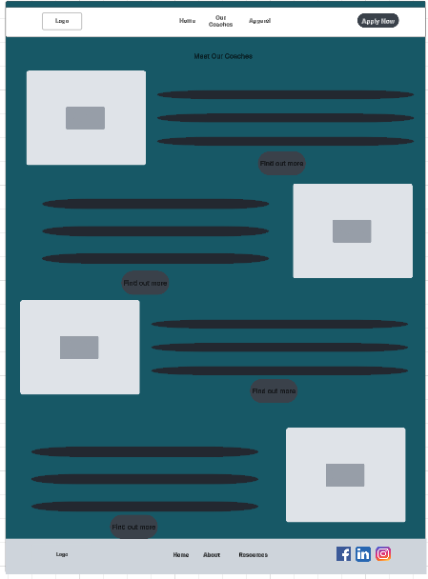

Structure:
I have used a modular grid layout alternating coach profiles. Each profile has an image, a text section with 3-5 bullet points about the coach and their experience/ expertise and another call-to-action button “Find Out More”. The alternating layout of the page uses repetition and symmetry to improve visual balance and predictability; this adds to the aesthetic and minimalist design. The repeating profile blocks with consistent spacing and alignment allows users to scan information easily and compare the information according with Gestalt’s principles of similarity and alignment. I have reduced the cognitive load on the user again by having information separate for each coach as well as minimising the information present on the screen.
Section heading “Meet Our Coaches”:
This section title introduces the page content for the user allowing users to immediately infer the purpose of the section.
Coach profile Section:
Providing a picture of each coach abides to Heuristic recognition over recall allowing users to recognize each coach visually rather than relying on recall from memory. Each coach profile has a clear call to action button minimizing decision making effort according to Hick’s Law. The call-to-action buttons abide to Fitts’ Law ensuring there is enough size and padding the make the buttons easy to click. The Phrase “Find out more” also encourages curiosity in the user to continue exploring. Clean and consistent separation between each profile ensures visual rhythm and simplicity and follows the aesthetic and minimalist design of the page.
Originally I wanted to create the coach profiles using a flashcard design however after doing further research into similar coaching websites I opted to keep my design as most other websites use a flashcard style and after a meeting with the clients they liked my design better and they want to stand out from other coaching services.
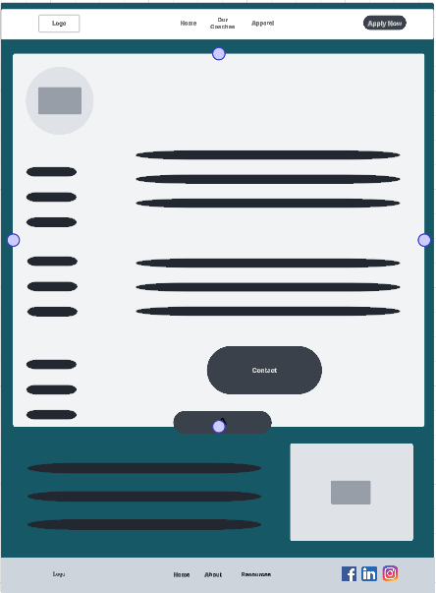
After a user clicks the “Find Out More” button a section will extend down allowing the user to find out more information about the coach. The goal of this is to provide a user with a deeper insight into the coaches’ background and specific skills.
Coach profile section:
The photo of the coach in the top left of this section allows users to visually identify the coach going back to recognition over recall. I have applied Gestalt’s principle of Figure – Ground, the light background separates the content from the surrounding sections of the page. I have again used a “Contact” Call to action button. I used “Contact” as the wording feels direct to the user prompting engagement.

SiteMap:
The image below shows how the coaches, apparel, testimonials and application pages are connected to the homepage.
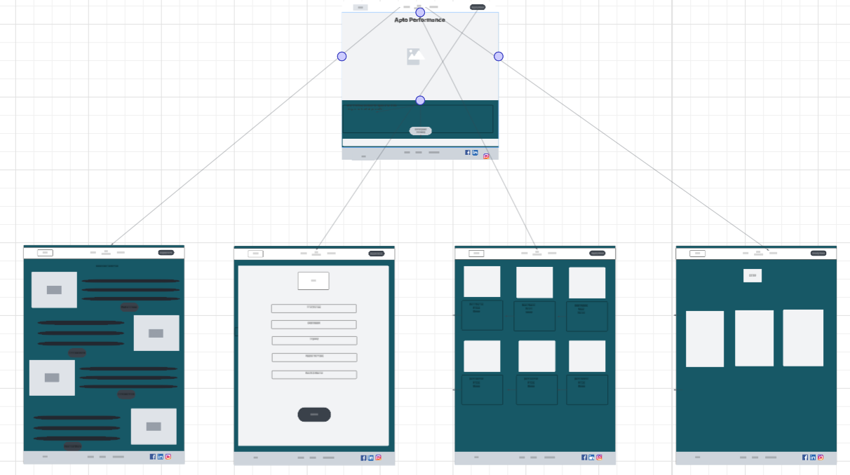

Section 3:
Usability Testing plan:
I started with a cognitive walkthrough to understand how easily a new user can manoeuvre through the website.
The first walkthrough will see if a user can easily navigate to a coach. Use the “find out more” button ensuring that the section drop down to reveal more information as well as making sure that the “Contact” button takes the user to the application page whilst also checking that the application is submitted correctly.
Walkthrough 1:
- Open Site
- Navigate to the Coaches page
- Scroll to “Alasdair”
- Click the “Find out more” button
- Click “Contact” button
- Fill out information on application page
- Submit application

The second walkthrough ensures that a user can navigate to the apparel and is able to view both images of the front and back for the hoodie item.
Walkthrough 2:
- Open site
- Navigate to Apparel page
- Use the arrows on “Apto Hoodie – Black” to see the back view
- Use the arrows on “Apto Hoodie – Black” to revert to front view

The third walkthrough is testing that a user can navigate to the testimonials and making sure that the flashcards turn over when being hovered on.
Walkthrough 3:
- Open site
- Navigate to Testimonials page
- Hover over the 1st picture and read the testimonial
- Hover over the 2nd picture and read the testimonial
- Hover over the 3rd picture and read the testimonial

System Usability Scale question evaluation:
This testing was performed on the 7th of November during the 4:30pm Tutorial.
 | Student 1 | Student 2 | Student 3 | Student 4 | Student 5
I Think that I would like to use this system frequently | 5 | 4 | 5 | 4 | 3
I found the system unnecessarily complex | 1 | 1 | 1 | 2 | 1
I thought the system was easy to use | 5 | 4 | 5 | 4 | 4
I think that I would need the support of a technical person to be able to use this system | 1 | 1 | 1 | 1 | 1
I found the various functions in this system were well integrated | 5 | 5 | 4 | 4 | 5
I thought there was too much inconsistency in the system | 1 | 1 | 1 | 1 | 1
I would imagine that most people would learn to use this system very quickly | 5 | 5 | 5 | 5 | 5
I found the system very cumbersome to use | 1 | 1 | 1 | 1 | 1
I felt very confident using the system | 5 | 4 | 5 | 5 | 4
I needed to learn a lot of things before I could get going with this system | 1 | 1 | 1 | 1 | 1
Overall SUS Score | 100 | 92.5 | 97.5 | 90 | 90

With an average SUS score of 94.0 the website falls in the Excellent range on the SUS scale. This means that users found the system intuitive and efficient.
One response I gathered from observing the SUS evaluation is that some users tried to use the logo on the top left of each page to go back to the home page. The logo on the webpage is not linked, this led to some users being confused for a moment before using the navigation bar to go home. This behaviour reflects Nielsen’s Heuristic #4 Consistency and standards where users rely on widely accepted web conventions to predict how an interface will behave. Users expect an easy way to navigate throughout the website, preventing this reduces the users’ sense of control. To fix this I would make the Logo a clickable link that takes users back to the home page
Post delivery testing:
When the website is finished testing will be more focused on retrieving real world feedback from users. In this stage I aim to identify ongoing pain points and evaluate the success of major design decisions. I will do this by making use of post purchase surveys, post sign up surveys and analytics data such as heatmaps and signup conversions. On top of this I a focus group will be held after a few weeks of the site being active to gather further information about user experience and note any suggestions from users about future updates to the website.
Participant selection for usability testing:
The participants used for usability testing will be amateur student lifters who are looking for easy access to coaching information as well as Full-time workers who are beginner lifters who need a more structured program that is flexible around their work. Participants will range from 18-30 years old.

Section 4:
By interacting with my group in tutorials I was able to get different perspectives on the challenges we were facing. It especially helped when we were learning how users interact with digital services as I was able to see how the other members of my group felt about the websites and the difference in how we interacted with the websites. During the tutorials I learned how to develop personas with user stories from their perspective which helped when creating my personas and user stories.

Section 5:
The website consists of 5 pages:
- Home page – Gives a short introduction to the website. I implemented a slideshow of pictures to give the user a visual representation of what the website is about.
- Coaches page – This page is key for users to find information on what coaches are available and what each coach specialises in. The “find out more” feature is used so that users aren’t overwhelmed by information and can easily and quickly understand if that particular coach is what they are looking for. This also adds a personal factor as the user feels like they are getting to know the coach. I added the contact button so that users can easily continue to the application. I chose “Contact” as it once again makes a user feel like they are able to immediately contact the coach and get started.
- Apparel page – Even though apparel is not a core feature to a powerlifting coaching service I have implemented this as I think it builds the brand identity. Branded apparel helps athletes feel like they are a part of the brand themselves and strengthens the emotional connection between coaches and lifters. In this prototype version users are unable to add items to a basket/checkout as the focus is evaluating the layout and information hierarchy.
- Testimonials page – This page features images of athletes as well as direct quotes from the athletes. I implemented this section to communicate trust and credibility to a user which are both crucial factors when considering coaching services.
- Application page – The application page is a core feature of the website as it is the end goal for most users. I have implemented a Form style application requiring basic information such as a users’ name, contact details and what they are applying for. Currently a user cannot submit an application as this is a prototype and it aims to evaluate the layout of the page.

File name | Explination
AptoPerformance.html | Home page for website
Coaches.html | Webpage displaying coaches
Apparel.html | Webpage displaying apparel
Testimonials.html | Webpage displaying client testimonials
Application.html | Application page
Stylesheet.css | Stylesheet for entire website
Images folder | All of the images user for the website are stored here

- All images were sent to me by Apto performance.
- I used Lucid.app to create my mockups and sitemap.

